Dendrocygna arcuata Wandering Whistling-Duck
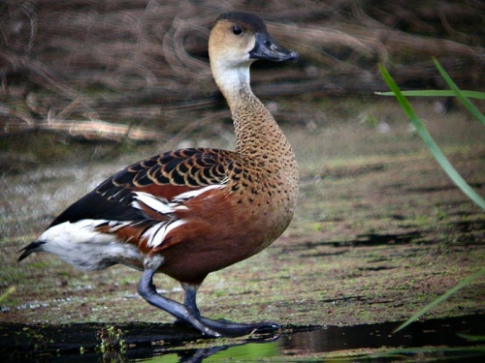
http://www.planetofbirds.com/Master/ANSERIFORMES/Anatidae/pics/Wandering%20Whistling%20Duck.jpg
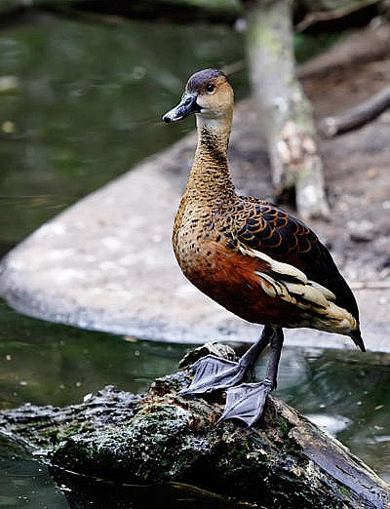
http://www.summagallicana.it/lessico/d/dendrocigna.htm

Anas platyrhynchos Mallard
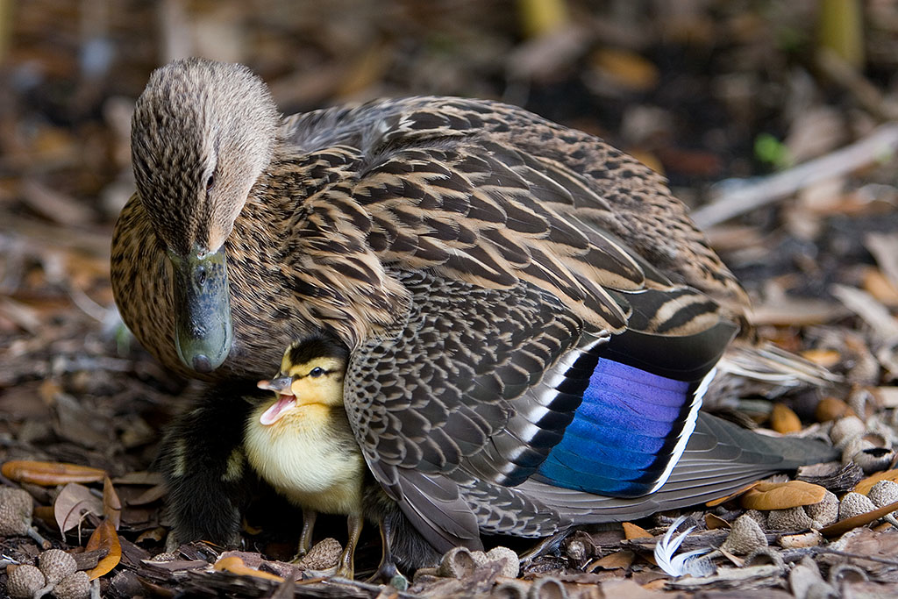
http://www.joshhillman.com/photos/Anas_platyrhynchos-IMG_0067.jpg
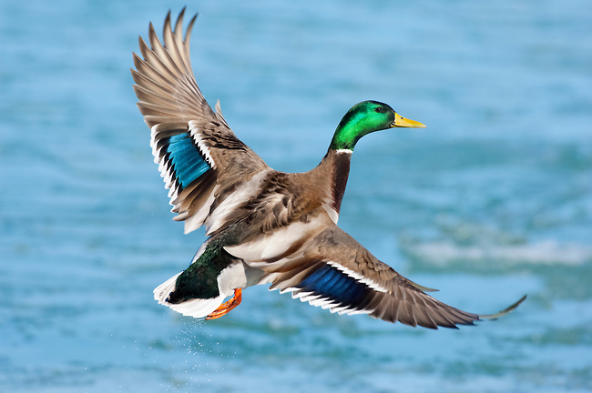
http://cdn.c.photoshelter.com/img-get/I00007fWci.1H7gg/s/650/650/Mallard-20070223-104118-DSC0148.jpg

Anas zonorhyncha Eastern Spot-billed Duck
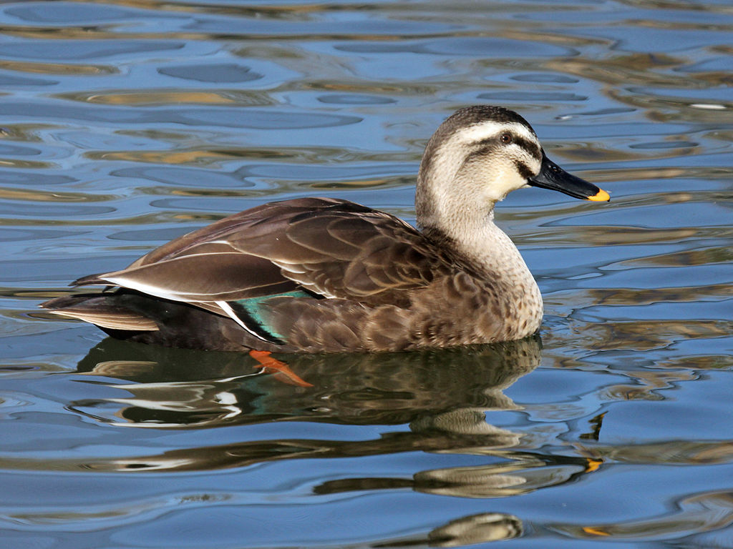
http://upload.wikimedia.org/wikipedia/commons/thumb/4/41/Duck,_Spot_Billed_specifically_Eastern_Spot_Billed_RWD.jpg/1024px-Duck,_Spot_Billed_specifically_Eastern_Spot_Billed_RWD.jpg
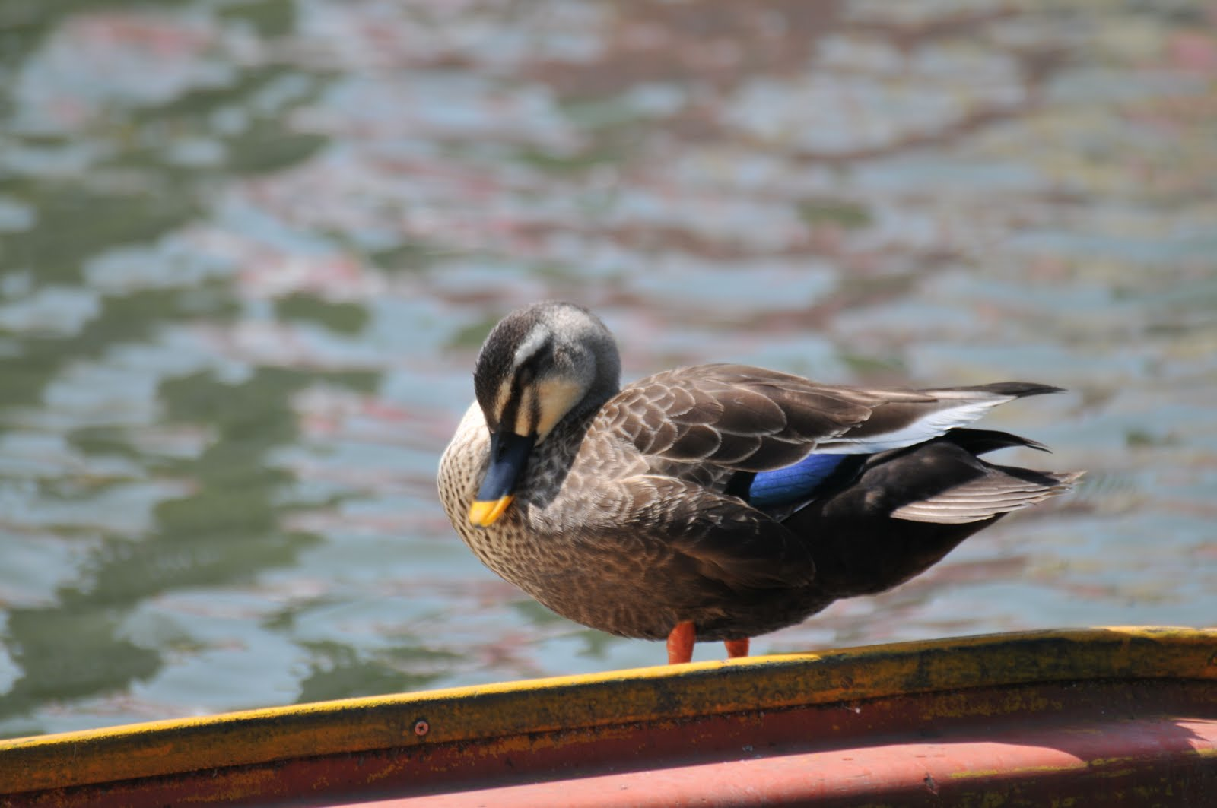
http://degullacion.blogspot.com/2010/06/japan-17-24-may-2010-part-3.html
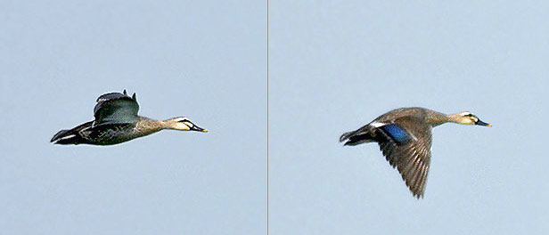
http://orientalbirdimages.org/search.php?Bird_ID=2911&Bird_Image_ID=30058&p=17

